Common API Security Methods – JWT (JSON Web Tokens)

🔐 What is JWT (JSON Web Tokens)
# Source: AI Source: Provided by: [Data Path: Persons Table -> ID Column: 1, Name_En Column: Motasem Essam] -> From: [ChatGPT] on [1/19/2026]
JWT (JSON Web Token) is a compact, secure way to transmit information between client and server as a signed token. It is commonly used for authentication and authorization in APIs.
👉 Think of JWT as a digital ID card that proves who you are and what you’re allowed to do.

🔑 Key Concepts
# Source: AI Source: Provided by: [Data Path: Persons Table -> ID Column: 1, Name_En Column: Motasem Essam] -> From: [ChatGPT] on [1/19/2026]
- Token-Based Authentication → No sessions stored on the server (stateless)
- Self-contained → Token includes user info and permissions
- Signed → Prevents tampering

🧱 Structure of a JWT
# Source: AI Source: Provided by: [Data Path: Persons Table -> ID Column: 1, Name_En Column: Motasem Essam] -> From: [ChatGPT] on [1/19/2026]
A JWT has 3 parts separated by dots:
header.payload.signature
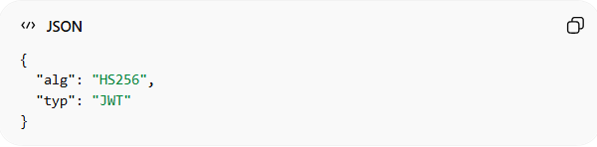
1️⃣ Header
{
"alg": "HS256",
"typ": "JWT"
}
2️⃣ Payload (Data)
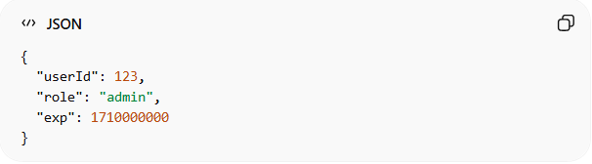
{
"userId": 123,
"role": "admin",
"exp": 1710000000
}
3️⃣ Signature
- Ensures the token was not modified

🧱 Example: Using JWT in API
# Source: AI Source: Provided by: [Data Path: Persons Table -> ID Column: 1, Name_En Column: Motasem Essam] -> From: [ChatGPT] on [1/19/2026]
Request
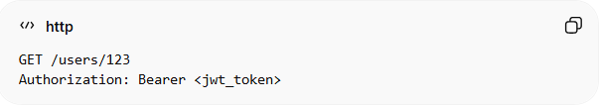
GET /users/123
Authorization: Bearer <jwt_token>
What Happens
- Client sends JWT
- Server verifies signature
- If valid → extract user info
- Process request

⚙️ How JWT Authentication Works
# Source: AI Source: Provided by: [Data Path: Persons Table -> ID Column: 1, Name_En Column: Motasem Essam] -> From: [ChatGPT] on [1/19/2026]
- User logs in (username/password)
- Server generates JWT
- Client stores token (e.g., local storage)
- Client sends token with every request
- Server validates token

✅ Advantages
# Source: AI Source: Provided by: [Data Path: Persons Table -> ID Column: 1, Name_En Column: Motasem Essam] -> From: [ChatGPT] on [1/19/2026]
- Stateless → no session storage needed
- Fast and scalable
- Works well with microservices
- Contains user info (no DB lookup needed sometimes)

❌ Disadvantages
# Source: AI Source: Provided by: [Data Path: Persons Table -> ID Column: 1, Name_En Column: Motasem Essam] -> From: [ChatGPT] on [1/19/2026]
- Cannot easily revoke tokens (until expiration)
- Token size is larger than API keys
- Security risk if token is stolen

⚠️ Common Mistakes
# Source: AI Source: Provided by: [Data Path: Persons Table -> ID Column: 1, Name_En Column: Motasem Essam] -> From: [ChatGPT] on [1/19/2026]
- Storing sensitive data in payload ❌
- Using long expiration times ❌
- Not validating signature ❌
- Storing token insecurely (e.g., localStorage without care) ❌

🔐 Best Practices
# Source: AI Source: Provided by: [Data Path: Persons Table -> ID Column: 1, Name_En Column: Motasem Essam] -> From: [ChatGPT] on [1/19/2026]
- Use short expiration time
- Store tokens securely (prefer HttpOnly cookies)
- Always use HTTPS
- Use refresh tokens for long sessions
- Validate signature and expiration

⚖️ JWT vs API Keys vs OAuth 2.0
# Source: AI Source: Provided by: [Data Path: Persons Table -> ID Column: 1, Name_En Column: Motasem Essam] -> From: [ChatGPT] on [1/19/2026]
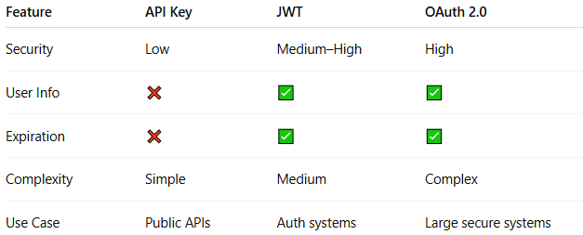
Feature | API Key | JWT | OAuth 2.0
Security | Low | Medium–High | High
User Info | ❌ | ✅ | ✅
Expiration | ❌ | ✅ | ✅
Complexity | Simple | Medium | Complex
Use Case | Public APIs | Auth systems | Large secure systems

💡 Summary
# Source: AI Source: Provided by: [Data Path: Persons Table -> ID Column: 1, Name_En Column: Motasem Essam] -> From: [ChatGPT] on [1/19/2026]
JWT is a secure, stateless way to authenticate users and pass their identity in API requests using signed tokens.

